***LONDON ROAD METHODIST CHURCH***

***MOTHERING SUNDAY***

***30 MARCH 2025***

***Scripture passage this week: Luke chapter 15 verses 1 to 3 and 11b to 32***

***The Prodigal Son***

***This morning’s appointed preacher, Mr. Ebo Ofori-Quaah….***

….. is unable to be with us. The service will be led by our Worship Leaders.

***A working group***

At the Mission Group meeting at Priory Methodist Church on Wednesday evening, to discuss further the idea of the four churches becoming a single church on the four sites, it was suggested that a working group be set up to consider this further. Each church has been asked to invite several people to join the group. Would you be interested? If so, or if you would like to know more about this, please have a word with Andrew or John.

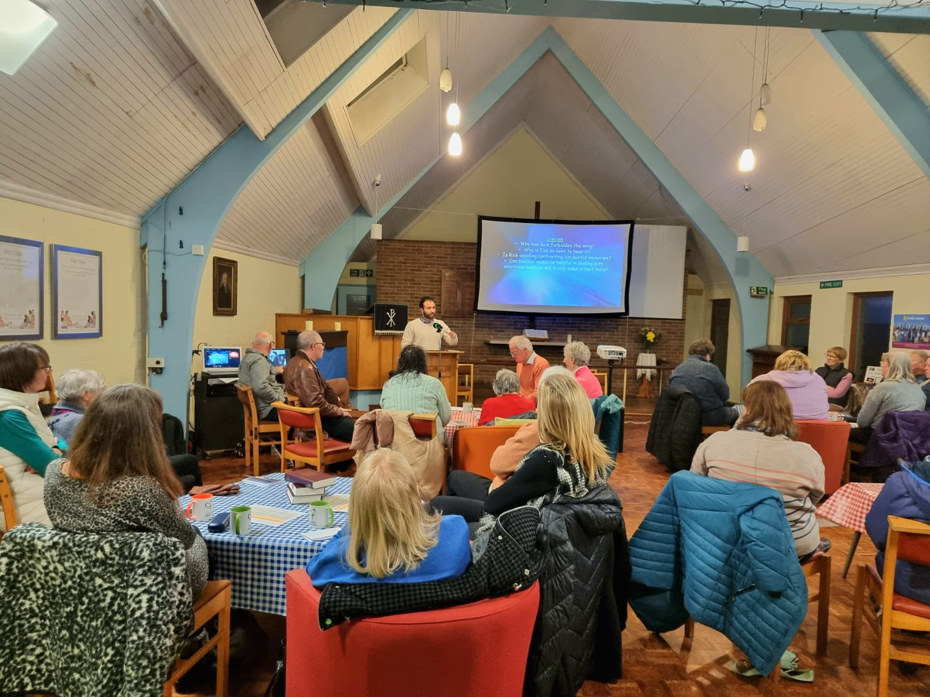***Lent course***

Last Tuesday saw the highest attendance so far at this year’s Lent course with 28 people present. The fourth session this Tuesday at 7.30 pm will be led by Mrs. Liz Little. The title of this session is “Standing up for our beliefs, and Torn between love and virtue.” It has been good to hear very enthusiastic feedback about the course.

***The week ahead.***

Tuesday 7.30 pm Lent course session 4

Thursday 9.15 to 11.15 am Jolly Tots

***Coming soon***

Saturday 12th April Noon to 2 pm Messy Church

***Our services for the next few Sundays***

April 6th 2.30 pm Café worship led by ourselves

April 13th 9.30 am Palm Sunday worship at St. Michael and All Angels

April 20th 10.30 am Easter Sunday Holy Communion service Rev. Chris Sandy

April 27th 2.30 pm Mr. Paul Burgin

***From the hymn book***

For the beauty of each hour of the day and of the night, hill and vale, and tree and flower, sun and moon and stars of light. *Folliott Sandford Pierpoint (1864)*

*A prayer bowl is available on the table near the front of the church for your prayers.*

*Any donations of items for the Food Bank can be placed in the large box in the vestibule.*

*Bedford Food Bank uses the hall as a distribution point on Thursdays from 1.30 to 3.30 pm.*